Our Ref: JGW/GD Direct line: 01792 513402
Your Ref: Email : j.g.williams@swansea.ac.uk
Date: 1st February 2012

To whom it may concern

Project proposal to improve existing and further develop Gastrointestinal Endoscopy Services and Training in Bangladesh
I write in my capacity as Clinical Lead for Gastroenterology in Abertawe Bro Morgannwg University Health Board to confirm our support for this proposal. We will be delighted to support the development of gastrointestinal endoscopy in Bangladesh in the way proposed.

Professor J G Williams
Consultant Gastroenterologist
Clinical Lead for Gastroenterology: ABMU Health Board
Professor of Health Services Research, College of Medicine, Swansea University
Director: Health Informatics Unit, Royal College of Physicians of London

Appendix I

Bangladesh Endoscopy Training Project Report
Visit by Dr Mesbah Rahman, Dr Dafydd Richards, Dr Umakant Dave, Mark Hillier and Sianed Dafydd.
We selected Bangladesh as our project venue as it is one of the poorest countries amongst the booming economies of Asia (ranked 161 to 183 in world ranking in various parameters by the UN and WHO). One of the members in our team has connection with Bangladesh which helped to set up vital links.
Prior to our visit, we conducted a postal survey of ERCP services in Bangladesh. This work has been accepted for a poster presentation at the "World Congress of gastroenterology- Gastro2013". A five member team visited Bangladesh for two weeks (January-February 2013). We conducted two days of seminars covering advances in gastroenterology/endoscopy in venues across the country along with local speakers and delivered keynote lectures in the Bangladesh Gastroenterology Society (BGS) annual conference. We conducted the first ever full day of live ERCP workshop (video link between Dhaka Medical College hospital and BGS conference venue) in Bangladesh. We also conducted the first ERCP/Endoscopy Assistants' hand-on workshop and the first ever hands-on ERCP workshop using models and accessories for ERCPists. We collected feedback from all the events we conducted and it was rated very good or excellent in almost all parameters.
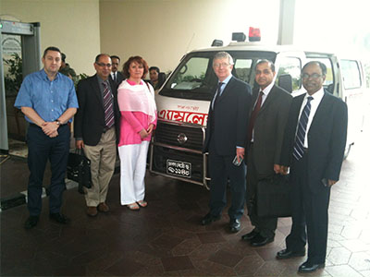
In addition to a successful first visit to Bangladesh, there have been other achievements. We have already established a good relationship with BGS office-bearers and have continued discussions on future developments. Two consultant gastroenterologists (key partners from Bangladesh) attended the BSG annual conference in Glasgow and spent 2 weeks in Wales as clinical observers. Student exchange is being established between the College of Medicine, Swansea and Dhaka Medical College. We have established a charity to continue the project named GASTROENTEROLOGY TRAINING ACADEMY (registered with charity commission, UK; registration no: 1150282http://www.charitycommission.gov.uk/find-charities/) and are organising fund raising events. We have participated in two live TV chat shows on Bangla TV to raise awareness about developments in endoscopy and this project. Two Bangladeshi gastroenterologists have joined the BSG as overseas members and another sixteen are in the process. We have provided some input to BGS in the development of draft guidelines on minimum quality standards in endoscopy. A draft proposal on a Bangladesh endoscopy training centre is being developed.
Cook Medical ® and Olympus ® supported the project. We thank BSG and hope BSG will continue to support this project.
Photograph showing travel arrangement from hospital to hospital (left to right: Mark Hillier (endoscopy nurse), Umakant Dave (consultant Gastroenterologist), Sianed Dafydd (radiology nurse), Dafydd Richards (consultant radiologist), Mesbah Rahman (consultant gastroenterologist) and Dr Rahman (BGS representative)).

Published in BSG newsletter, issue 21, winter 2013, page 5.

